NAME : SHISHU REG 2020CA089

ASSIGNMENT – PRACTICE

*Q1: Create the tables described below:*

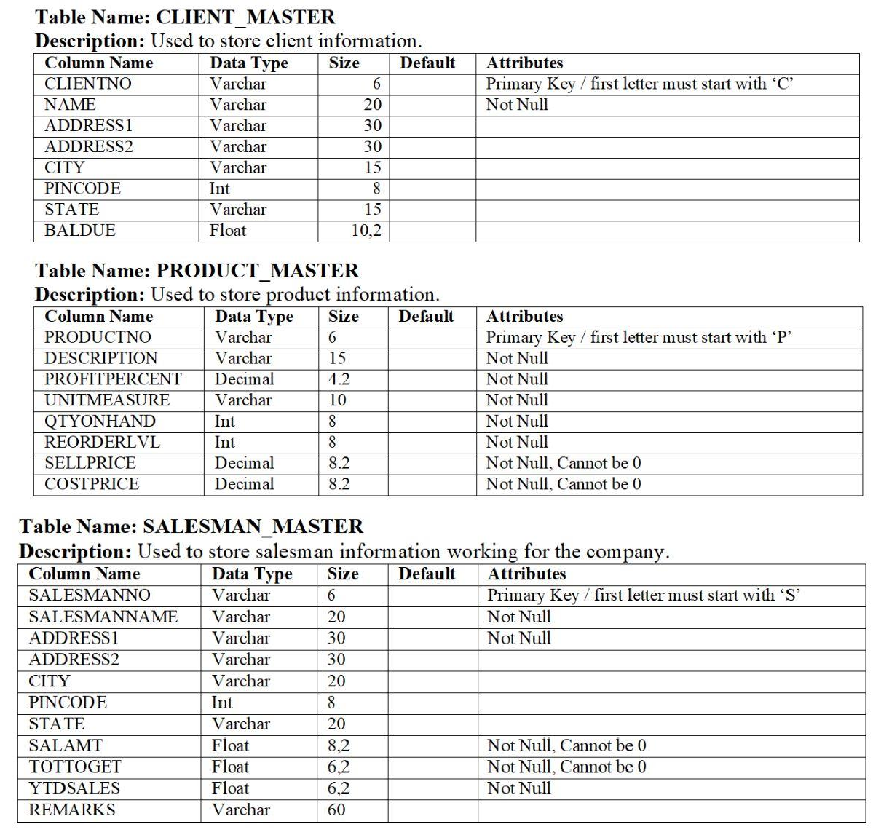

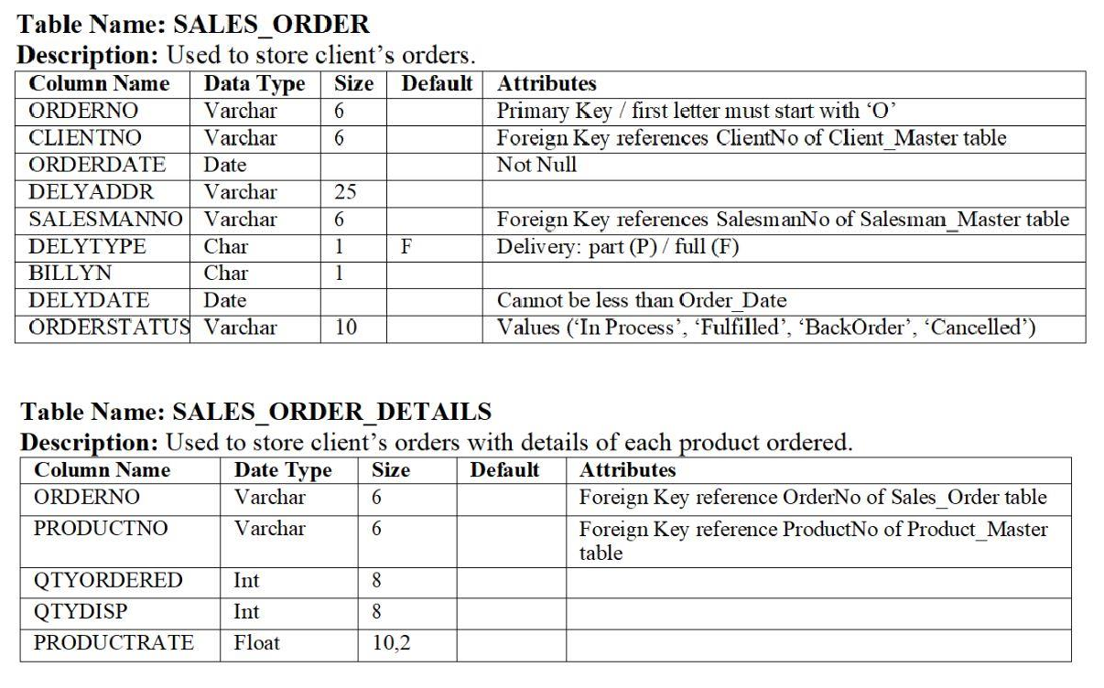

***Ans:***

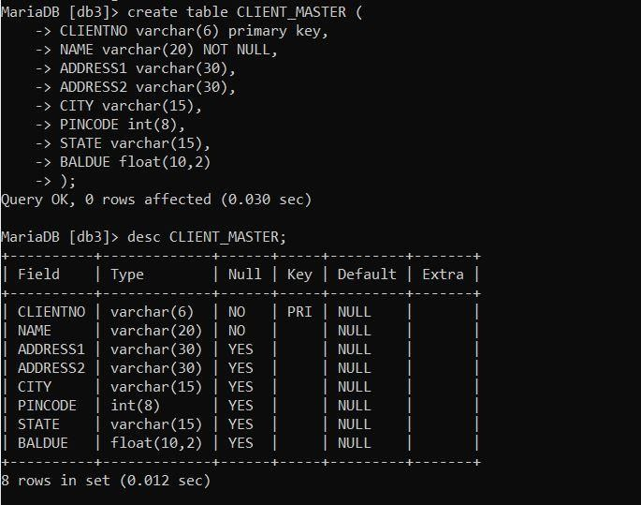

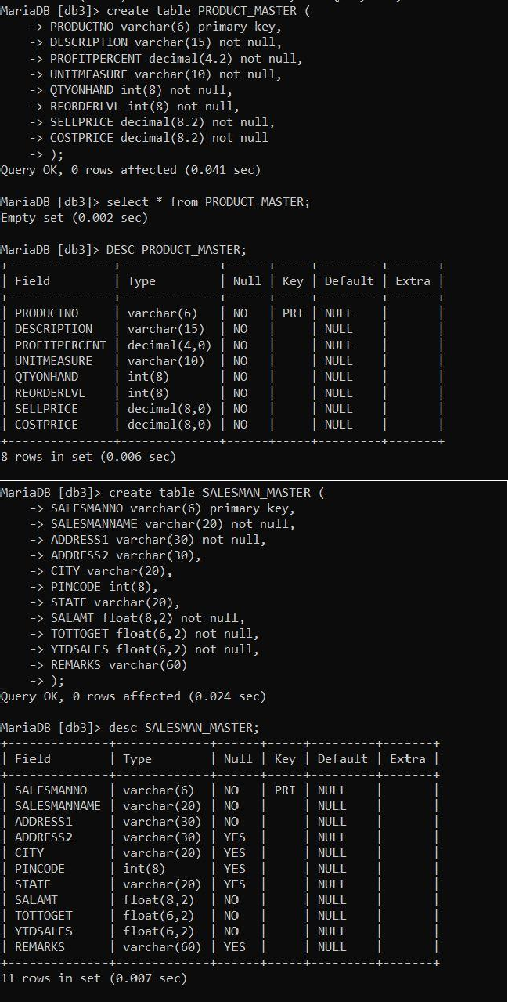

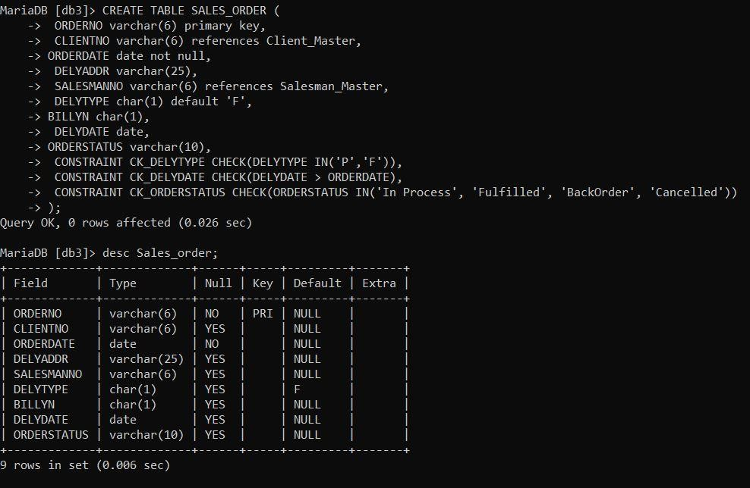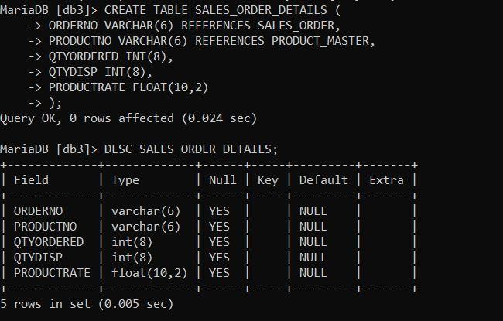

1. ***Insert the following data into their respective tables:***

***a. Re-insert the data generated for tables CLIENT_MASTER, PRODUCT_MASTER and SALESMAN_MASTER.***

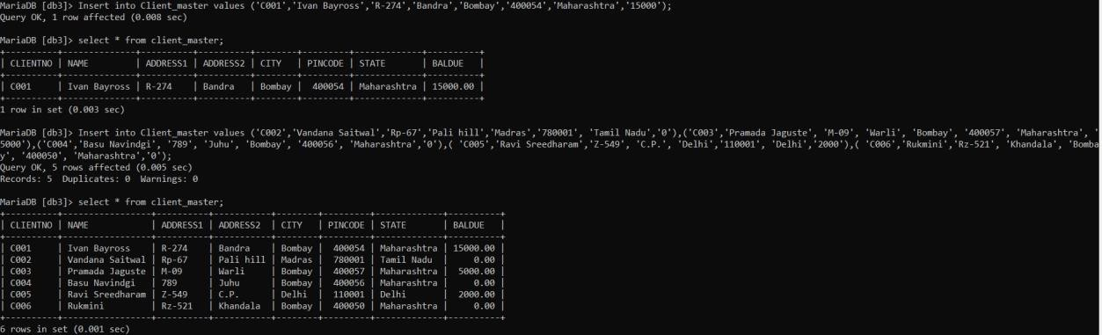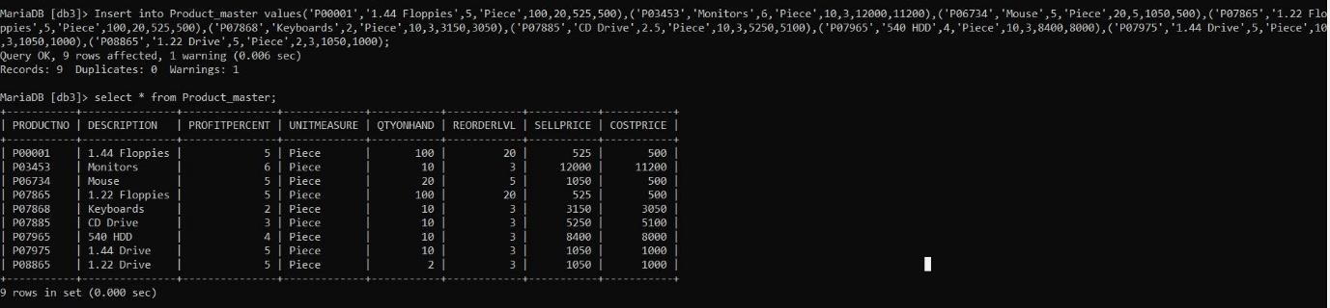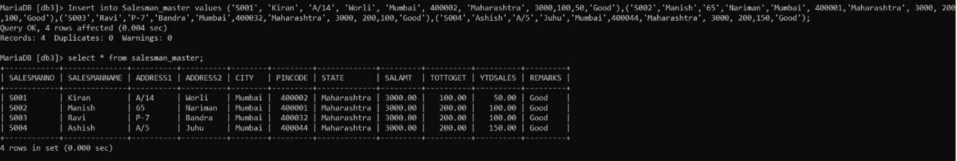

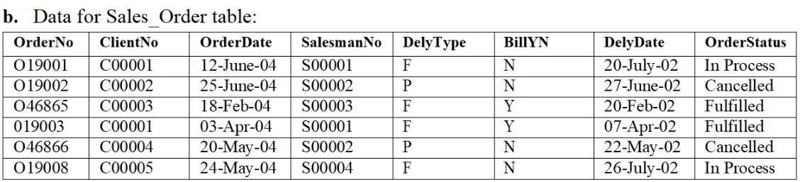



Ma iaDB [db3]> select from sales order;

0RDE8N0 | CLIENTNO ORDERDATE | DELYADD8

SALESRANNO | DELYTYPE | BILLYN | DELYDATE | ORDEASTATUS

|  |  |  |  |  |  |
| --- | --- | --- | --- | --- | --- |
| ***019001 | C00601***  ***019002 | C00002*** | ***2004-0o-12 | Maharestra***  ***2004-0o-25 | Makarastra*** | ***S00001***  ***500002*** | ***| P*** |  | ***2002-07-20 | In Process***  ***2002-0o-27 | Cancelled*** |
| ***019003 | C00001***  ***019008 | C00005***  ***046865 | C00603***  ***04686o | C00002*** | ***2004-04-03 | Meharastra***  ***2004-05-24 | Bikar***  ***2004-02-18 | Meharestra***  ***2004-05-20 | Bikar*** | ***S00001 S00004 S00003 S00002*** | ***| P*** | ***Y Y*** | ***2002-04-07 | Fulfilled 2002-07-2o | In Process 2002-02-20 | Fulfilled***  ***2002-05-22 | Cancelled*** |
| ***ñ oils in set ( 8. 885 sec )*** | | | | | |

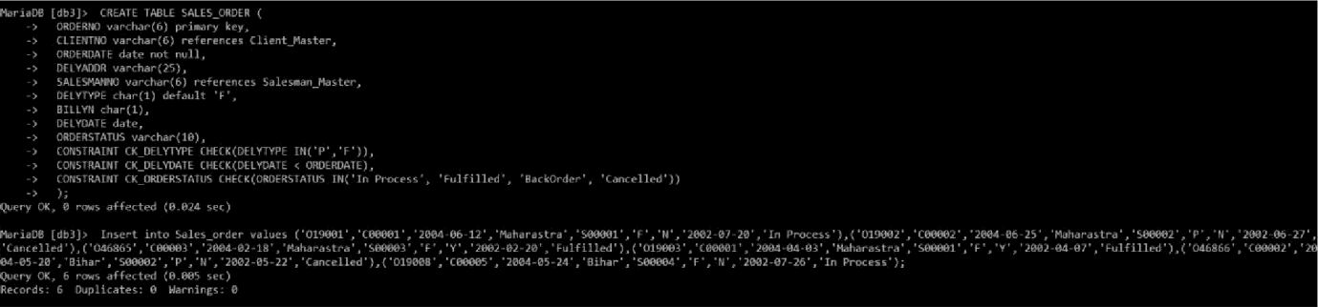

***c. Data for Sales OrdCr Details table:***

|  |  |  |  |  |
| --- | --- | --- | --- | --- |
| ***Orderho*** | ***Product o*** | ***QtyOrdereil*** | ***QtyDisp*** | ***ProductRaie*** |
| ***O19001*** | ***P00001*** | ***4*** | ***4*** | ***525*** |
| ***0 19001*** | ***P07965*** | ***2*** | ***1*** | ***8400*** |
| ***0 19001*** | ***P07881*** | ***2*** | ***1*** | ***5250*** |
| ***019002*** | ***P00001*** | ***10*** | ***0*** | ***525*** |
| ***046865*** | ***P07868*** | ***3*** | ***3*** | ***3150*** |
| ***046865*** | ***P07885*** | ***3*** | ***1*** | ***5250*** |
| ***046865*** | ***P00001*** | ***10*** | ***10*** | ***525*** |
| ***046865*** | ***P0345*** | ***4*** | ***4*** | ***1050*** |
| ***oisoos*** | ***r0aiss*** | ***s*** | ***z*** | ***loso*** |
| ***O1°9003*** | ***P06734*** | ***1*** | ***1*** | ***12000*** |
| ***046866*** | ***P07965*** | ***1*** | ***0*** | ***8400*** |
| ***046866*** | ***P07975*** | ***1*** | ***0*** | ***1050*** |
| ***0 19008*** | ***P00001*** | ***10*** | ***5*** | ***525*** |
| ***019008*** | ***l'07975*** | ***5*** | ***3*** | ***1050*** |

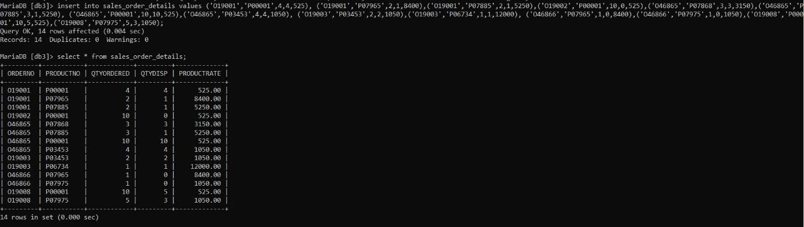

## *Using the tables created previously generate the SQL statements for the operations mentioned below. The tables in user are as follows:*

1. ***Client_Master***
2. ***Product_Master***
3. ***Salesman_Master***
4. ***Sales_Order***
5. ***Sales_Order_Details***
6. ***Perform the following computations on table data:***
7. ***List the names of all clients having ‘a’ as the second letter in their names.***

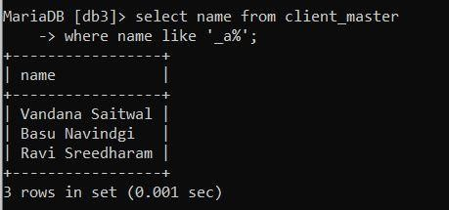

1. ***List the clients who stay in a city whose First letter is ‘M’.***

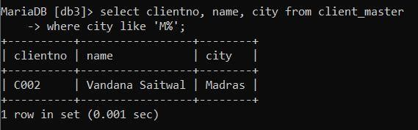

1. ***List all clients who stay in ‘Bangalore’ or ‘Mangalore’***

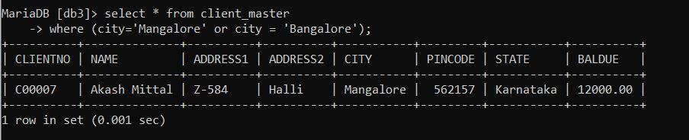

1. ***List all clients whose BalDue is greater than value 10000.***

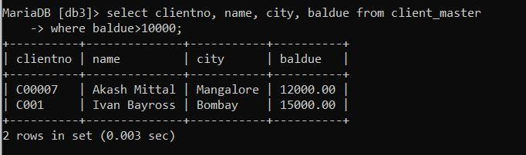

1. ***List all information from the Sales_Order table for orders placed in the month of June.***

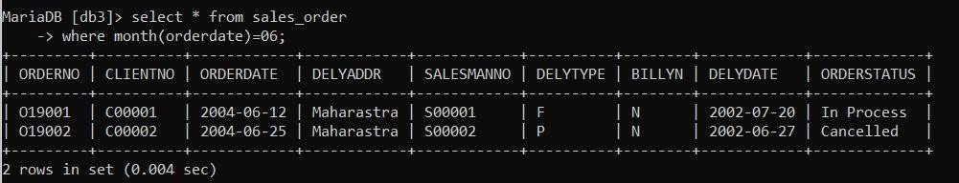

1. ***List the order information for ClientNo ‘C00001’ and ‘C00002’.***

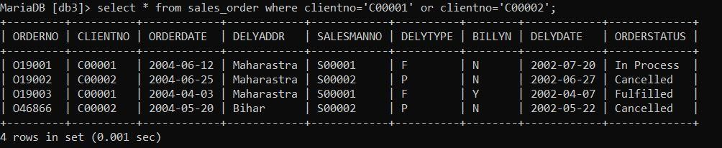

1. ***List products whose selling price is greater than 500 and less than or equal to 750.***

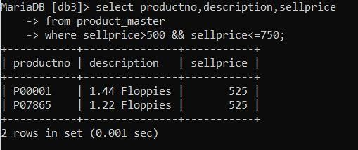

1. ***List products whose selling price is more than 500. Calculate a new selling price as, original selling price*.15. Rename the new column in the output of the above query as new_price.***

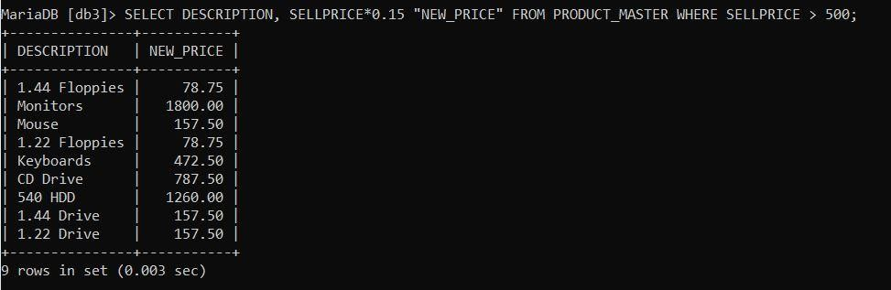

1. ***List the names, city and state of clients who are not in the state of ‘Maharashtra’.***

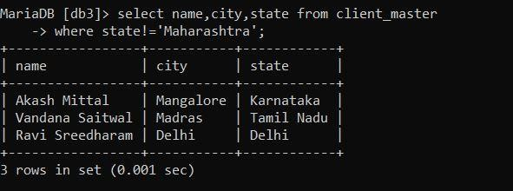

1. ***Count the total Int of orders.***

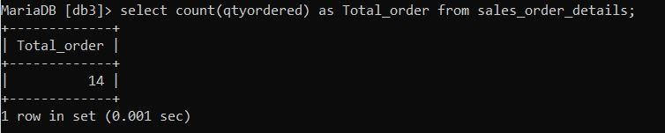

1. ***Calculate the average price of all the products.***

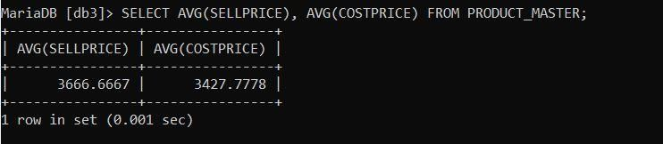

1. ***Determine the maximum and minimum product prices. Rename the output as max_price and mi9n_price respectively.***

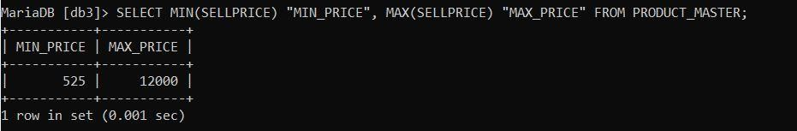

1. ***Count the Int of products having price less than or equal to 500.***

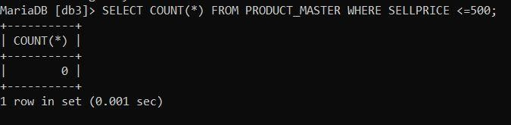

1. ***List all the products whose QtyOnHand is less than recorder level.***

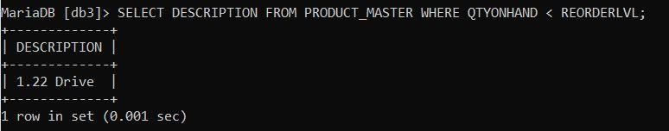

1. ***Exercise on Date Manipulation:***
   1. ***List the order Int and day on which clients placed their order.***

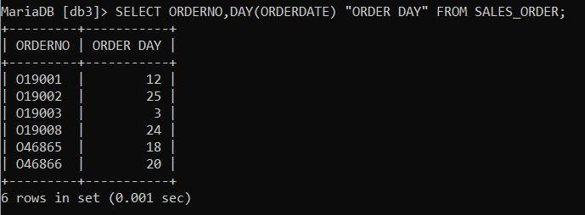

* 1. ***List the month (in alphabets) and date when the orders must be delivered.***

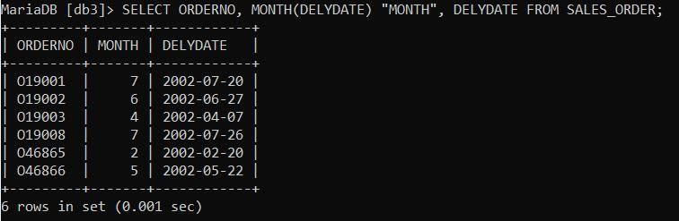

* 1. ***List the OrderDate in the format ‘DD-Month-YY’. E.g. 12-February- 02.***

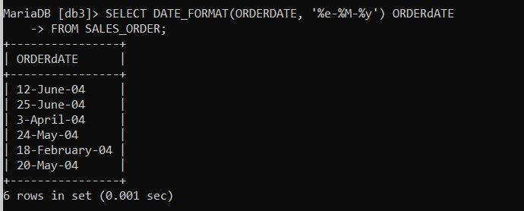

* 1. ***List the date, 15 days after today’s date.***

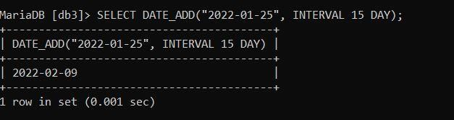

# *Exercises on using Having and Group By Clauses:*

1. ***Print the description and total qty sold for each product.***

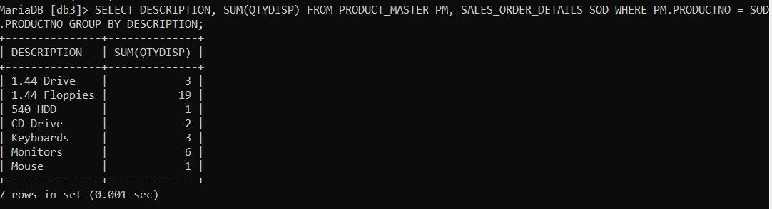

1. ***Find the value of each product sold.***

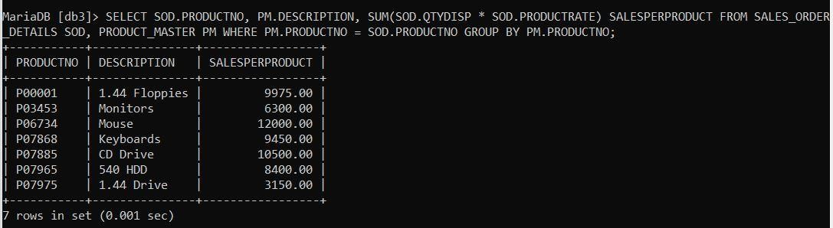

1. ***Calculate the average qty sold for each client that has a maximum order value of 15000.00.***

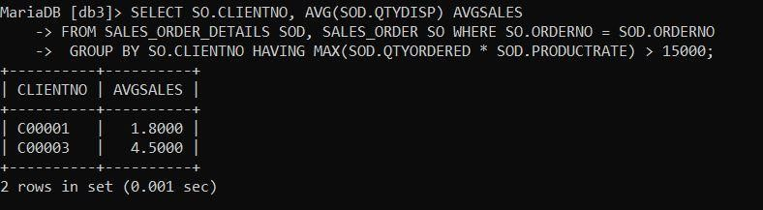

1. ***Find out the total of all the billed orders for the month of June.***

**

# *Exercise on Joins and Correction:*

1. ***Find out the products, which have been sold to ‘Ivan Bayross’.***

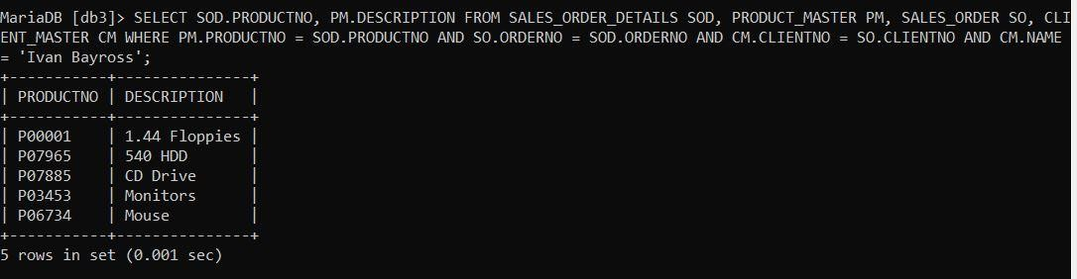

1. ***Find out the products and their quantities that will have to be delivered in the current month.***

**

1. ***List the ProductNo. and description of constantly sold (i.e. rapidly moving) products.***

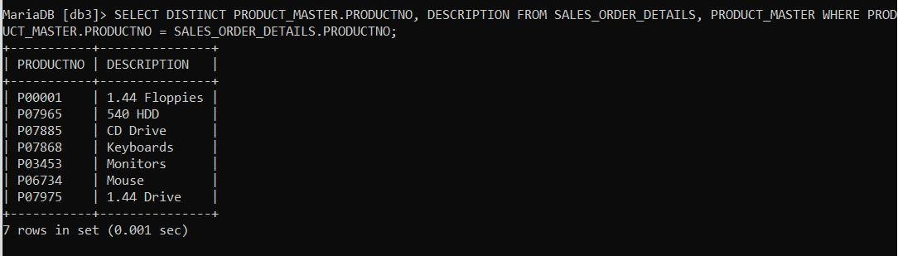

* 1. ***Find the names of clients who have purchased ‘Trousers’.***

**

* 1. ***List the products and orders from customers who have ordered less than 5 units of ‘Pull Overs’.***

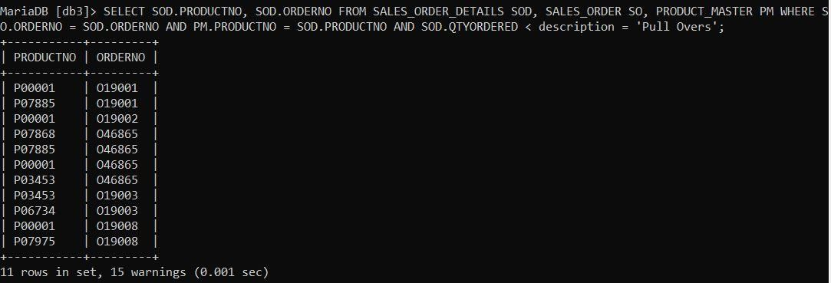

* 1. ***Find the products and their quantities for the orders placed by ‘Ivan Bayross’ and ‘Mamta Muzumdar’***

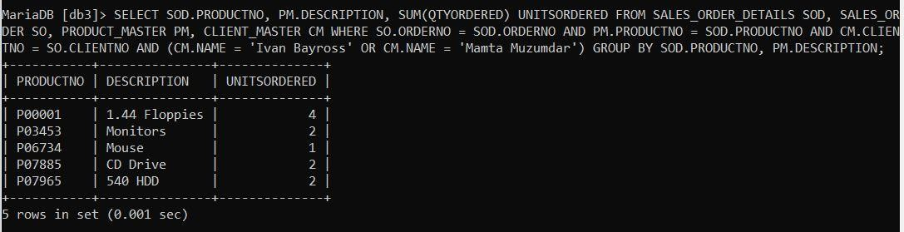

* 1. ***Find the products and their quantities for the orders placed by ClientNo ‘C00001’ and C00002’.***

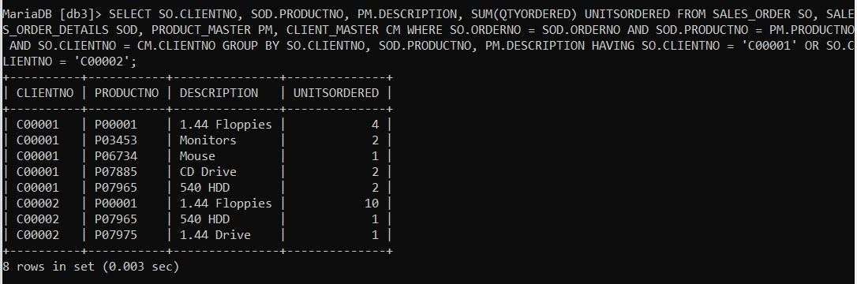

# *Exercise on Sub-queries:*

* 1. ***Find the ProductNo and description of non-moving products i.e. products not being sold.***

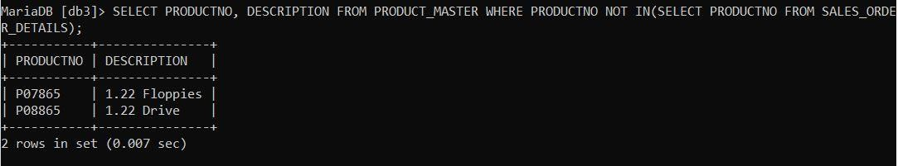

* 1. ***List the customer Name, Address1, Address2, City and PinCode for the client who has placed order no ‘O19001’.***

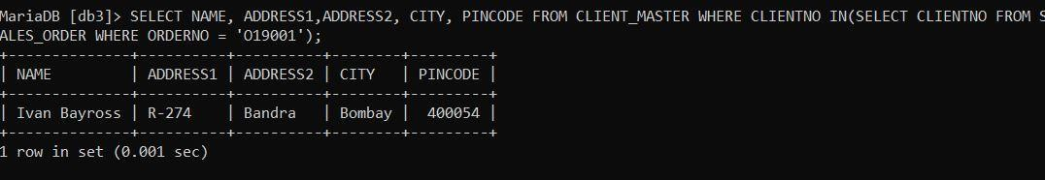

* 1. ***List the client names that have placed orders before the month of May, 02.***

**

* 1. ***List if the product ‘Lycra Top’ has been ordered by any client and print the Client_no, Name to whom it was sold.***

**

* 1. ***List the names of clients who have placed orders worth Rs. 10000 or more.***

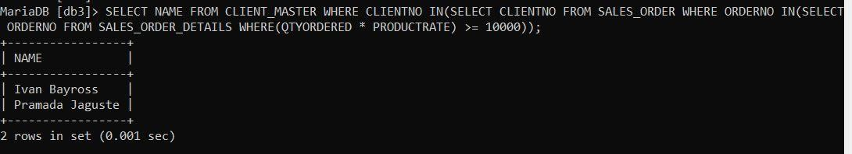

_____________________________________THE END_________________________________________